Project Design Phase-II
Data Flow Diagram & User Stories

Date | 17 February 2026
Team ID | LTVIP2026TMIDS90124
Project Name | DocSpot: Seamless Appointment Booking for Health
Maximum Marks | 4 Marks

Data Flow Diagrams:

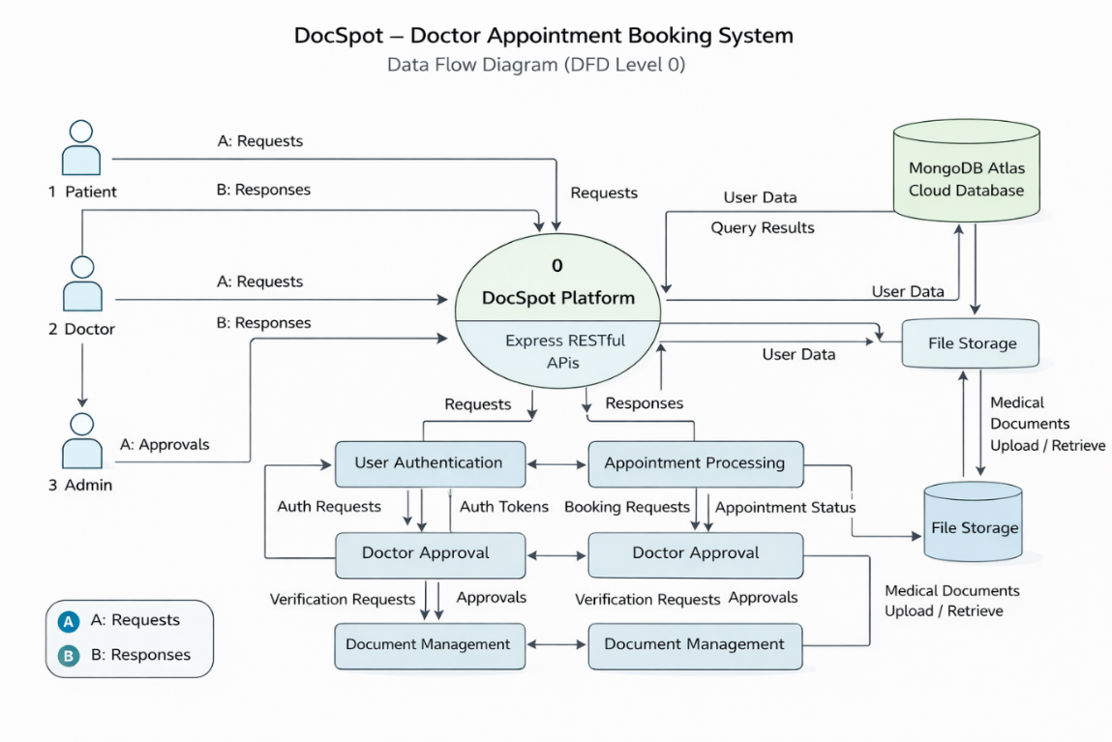

User Stories
User Type | Functional Requirement (Epic) | User Story Number | User Story / Task | Acceptance criteria | Priority | Release
Customer (Web User) | Registration | USN-1 | As a user, I can register using email and  password | Account created & dashboard accessible | High | Sprint-1
Customer (Web User) | Authentication | USN-2 | As a user, I can log in securely | Successful login redirects to dashboard | High | Sprint-1
Customer (Web User) | Doctor Listing | USN-3 | As a user, I can view available doctors | Doctor list loads from database | High | Sprint-1
Customer (Web User) | Appointment Booking | USN-4 | As a patient, I can book appointment with date & time | Appointment status shows “Pending” | High | Sprint-2
Customer (Web User) | Document Upload | USN-5 | As a user, I can upload medical documents during booking | File uploads successfully | Medium | Sprint-2
Doctor | Appointment Management | USN-6 | As a doctor, I can accept or reject appointment requests | Status updates to Scheduled/Rejected | High | Sprint-3
Administrator | Doctor Approval | USN-7 | As an admin, I can approve doctor registrations | Approved doctor visible in system | High | Sprint-3
Customer Care Executive | Notifications | USN-8 | As a user, I receive appointment updates | Notification displayed in dashboard | Medium | Sprint-4
Customer (Web User) | Appointment History | USN-9 | As a user, I can view booking history | Previous appointments visible | Medium | Sprint-5

